PH.D. SPECIAL EDUCATION
LEADERSHIP GRANT
INFORMATION SESSION NOVEMBER 12, 2008
Principal Investigators (PIs) for this grant:
Dr. Margaret King‐Sears mkingsea@gmu.edu
Dr. Frederick Brigham fbrigham@gmu.edu
Dr. Pamela Baker pbaker5@gmu.edu
Special Education Leadership Doctoral Grant ¹
Agenda*
2
Describe the grant’s purpose
Describe this doctoral program
Identify eligibility parameters
Clarify acceptance into PhD program must occur first
Explain grant financial support
Emphasize Service or Repay Obligation
Identify some frequently asked questions and responses
Describe grant selection process
Respond to questions
* This content is also located on the grant web site http://kihd.gmu.edu/PhDSpecialEducationLeadershipGrant

Ph.D. Special Education Leadership Grant
3
This Ph.D. Program consists of:
Major in Special Education
Minor in newly‐developed cognate on Special
Education Leadership
After reviewing content on the grant web site or hearing information at an Information Session, contact one of the Principal Investigators with your questions or for further discussion.

Grant Purpose
The primary purpose for this grant is to prepare educators who are already certified and practicing in special education, general education, school administration, or related services areas to earn doctorates from George Mason University (GMU) with a major in Special Education and a minor in Special Education Leadership.
Throughout this three‐year (for full‐time doctoral students) or fouryear (for part‐time doctoral students) doctoral program, participants will focus on how legislation, regulations, and policy at the federal and state levels impact the practices used in classrooms where elementary and secondary students with high‐incidence disabilities (e.g., learning disabilities, emotional disturbance, high‐functioning autism, mild intellectual disabilities) and who may also have cultural and linguistic backgrounds are served.

Grant Purpose
This grant’s purpose is to prepare and support financially (and in other ways) doctoral students whose career goals include leadership and research that improve services and service delivery for students with high‐incidence disabilities who are found eligible for special education services under the Individuals with Disabilities Education Act.

Grant Purpose
Participants selected for this doctoral grant acquire knowledge and skills that ultimately lead toward their dissertation research. After graduating with their Ph.D., participants are obligated to continue in the field of education (whether at the college or university level, in state departments of education, in school systems, or other appropriate roles) for a specific period of time in leadership positions to:
- Disseminate their newly‐acquired expertise about teaching elementary and secondary students with high‐incidence disabilities.
- Continue to contribute to the research base in special education.
- Promote changes within organizational systems that increase capacity‐building for improved services for elementary and secondary students with high‐incidence disabilities.

Grant Participants’ Focus
We will select participants who have already demonstrated exceptional leadership skills and expertise in teaching elementary or secondary students with high‐incidence disabilities.
Participants selected for this grant must be committed to research on the design and delivery of specialized instruction for elementary and secondary students with high‐incidence disabilities in the least restrictive environment and other requirements per the Individuals with Disabilities Education Act.
Participants will have multiple opportunities during doctoral course assignments and doctoral grant seminars to acquire knowledge and skills that help them, in collaboration with the doctoral grant PIs, make decisions about their dissertation research topics and techniques.

Grant Participants’ Research Focus – some examples:
8
Dissertation research may focus on acquiring evidence of practices that promote students’ success in the least restrictive environment of a general education setting and achievement in general education curriculum.
Dissertation research may focus on educational services provided to students atrisk and with cultural and language differences prior to referral for assessment to determine eligibility for special education services, provided there is also a focus on determining eligibility and identifying instructional practices that benefit students with high‐incidence disabilities.
Participants may focus their dissertation research on Response to Intervention (RTI) models.
Dissertation research may focus on increasing administrator’s skills for supporting elementary and secondary students with high‐incidence disabilities.

Description of the Program
9
The rigorous and comprehensive doctoral curriculum expands the 20‐credit hour doctoral core curriculum (e.g., leadership seminars, quantitative and qualitative research courses) with a
- 21‐credit hour professional specialization in special education as the major area and a
- 12‐credit hour minor area in a newly‐developed Special Education Leadership concentration.
- Concluding with the 12‐credit hours for dissertation research, this doctoral program consists of a total of 65 credits that participants will complete within three or four years.
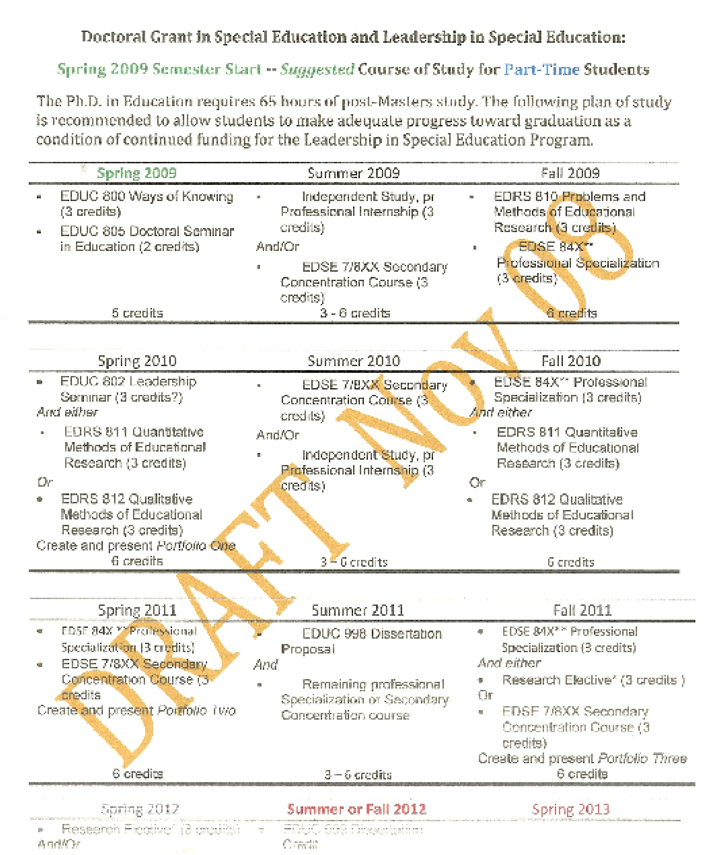
Example of Doctoral Program Sequence for Part‐time Participants beginning Spring 2009
10
Graduation Fall 2012
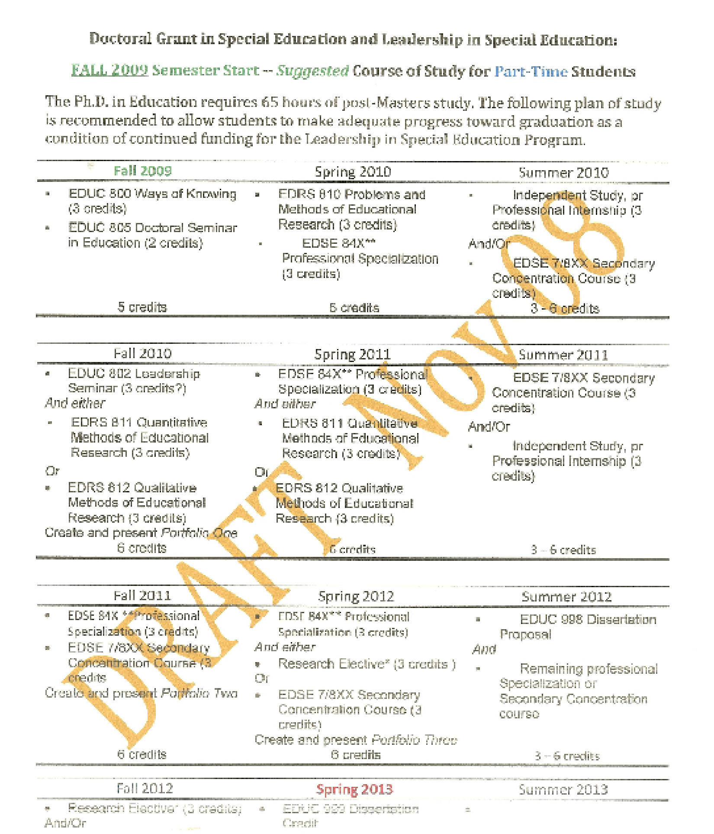
Example of Doctoral Program Sequence for Part‐time Participants beginning Fall 2009
11
Graduation
Spring 2013
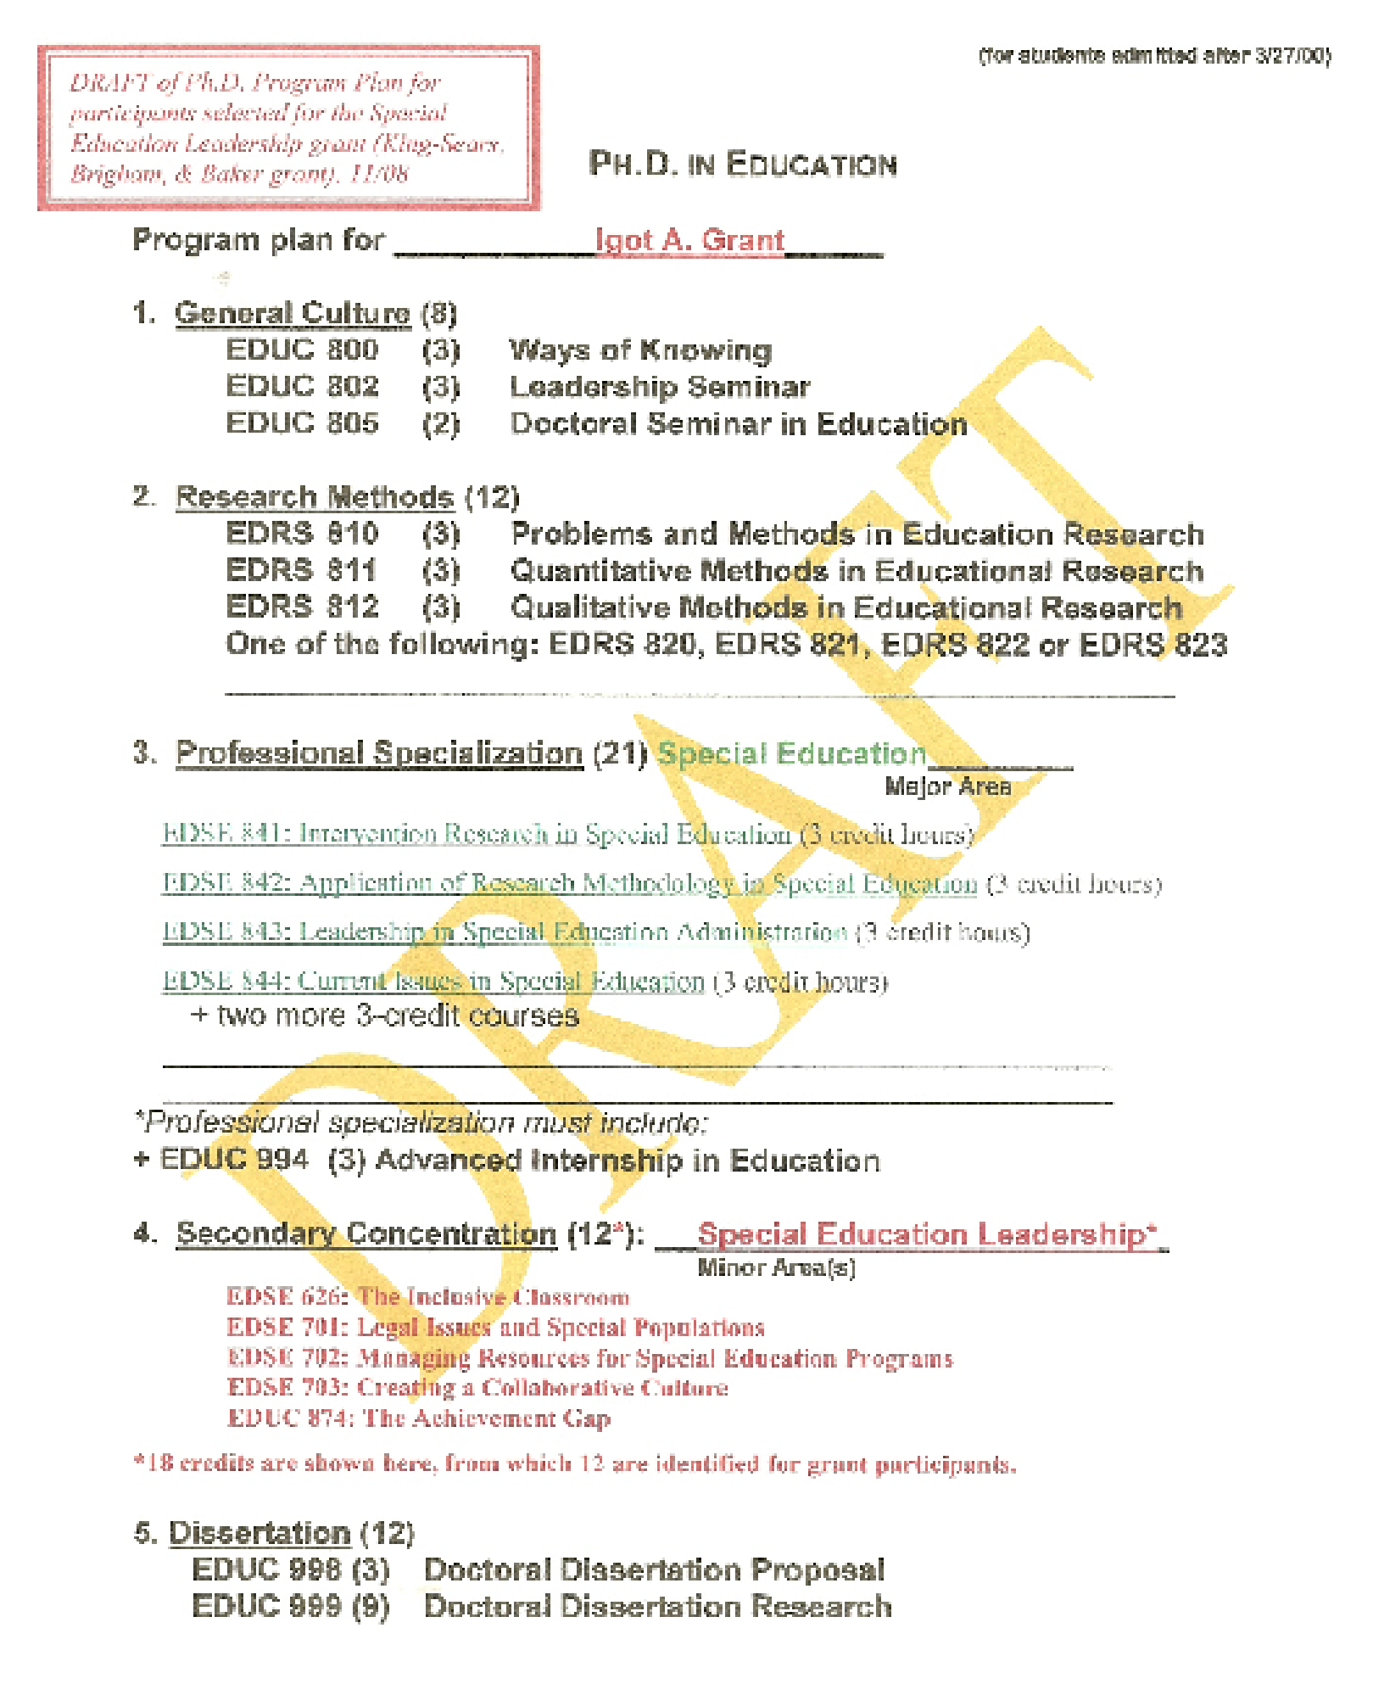
Example of Ph.D. Program Plan
12

Eligibility Criteria
Applicants for this Doctoral Grant must have or be able to commit to the following:
13
- Have a masterʹs degree from an accredited graduate program.
- Have full certification in special education, general education,
administration, or related service area .
- Completed a minimum three years of successful teaching experiences as
fully‐certified educators or related service personnel .
- Provide documentation of competence in serving school‐aged (elementary or secondary) students with high‐incidence disabilities who are culturally and linguistically diverse (service may be in any setting).
- Commit to continued service in special education as a condition for
accepting grant support.
- Provide documentation of emerging and/or documented evidence of
leadership qualities.
- Certify commitment to complete the doctoral program within three (full‐
time) or four (part‐time) years.
- Be admitted to the GMU Ph.D. Program.

Eligibility Criteria
Additionally, we desire applications from:
- Individuals with disabilities
- Individuals from culturally diverse and/or traditionally underrepresented groups in doctoral programs
- Individuals who desire full‐time immersion in the scholarly environment of this doctoral program
Applicants who are the most qualified will be selected, so full‐time completion of doctoral studies is not a required condition for all applicants.

Mason’s Ph.D. Program
How do I apply for Mason’s doctoral program?
All details for Ph.D. applications are located on the doctoral web site http://gse.gmu.edu/programs/phd/
Am I eligible for immediate admittance to Mason’s doctoral program? All details about eligibility for Mason’s doctoral program are located on the doctoral web site http://gse.gmu.edu/programs/phd/
If I want more information in general about Mason’s doctoral programs, where do I get that information?
All details about Mason’s doctoral program are located on the doctoral web site http://gse.gmu.edu/programs/phd/ There are also Ph.D. Program
Information Sessions offered on a regular basis. Dates, times, and locations are posted on the Mason’s doctoral web site.
- The Ph.D. Program Information Sessions are not designed to provide information about this grant!  Information about this grant is available on the grant’s web site and from this grant’s PIs.
- We strongly recommend that you attend a Ph.D. Program Information session if you have questions about the application process for Mason’s Ph.D. Programs. There is also extensive information located on the doctoral web site noted above.

Mason’s Ph.D. Program
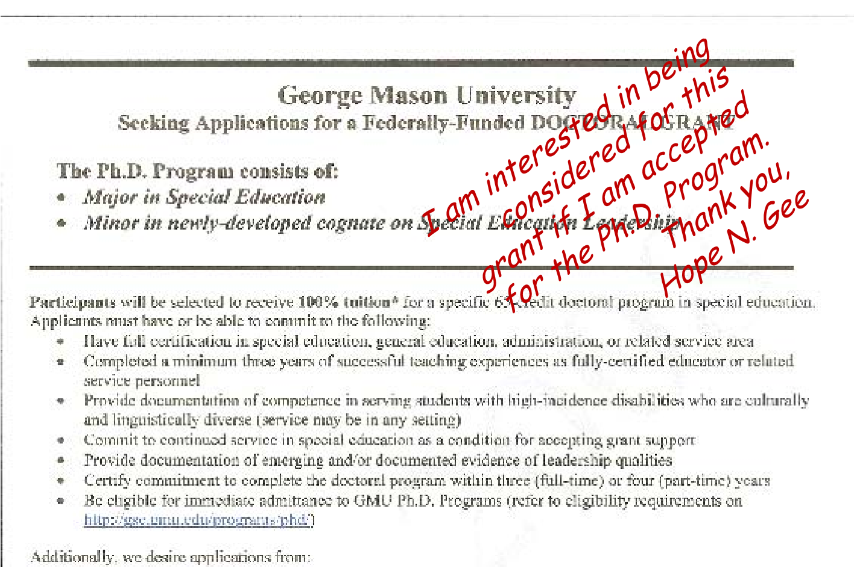
How do I make sure that I also apply for this grant when I apply for Mason’s doctoral program?
Do two things. First, insert the Information Flyer in your doctoral application so it is more visible to the Ph.D. application office that you are also applying for this grant. Write your name and a brief statement (e.g., “I am interested in applying for this grant, too.”) on the flyer. Second, contact one of the PIs (via email) to alert them that (a) you have submitted your doctoral application, (b) you desire to be interviewed by the PI team, and (c) you have read all the information about this grant and agree to conditions thereof.

Grant Financial Support
Can I apply for this grant, but use the financial support for another doctoral program at Mason in special education or another field?
No. Applicants should make sure that this doctoral grant matches their career goals and doctoral path.
If I am accepted into the doctoral grant program but have already completed some of the courses in the program, can tuition be paid on a retroactive or reimbursement basis?
No. Tuition coverage begins when you are accepted into the doctoral grant program.
How much of the tuition is paid from the grant?
100% of the specific 65‐credit program is paid from the grant. Whether you are an in‐state or out‐of‐state student, we have developed a financial package enabling the grant to cover 100% tuition.
Are there other types of financial support available through this grant?
Yes. We have financial support to offset or cover expenses for your attendance and participation in national conferences, purchase of textbooks, development of research materials, and a portion of living expenses. Refer to the grant’s financial package for more information.

Grant Research Assistant (GRA)
Must I work as a 10‐hour per week or 20‐hour per week Graduate Research Assistant (GRA) to be eligible for or accepted as a participant for this grant?
No. However, if you would like to increase professional experiences through working with one of the PIs or another faculty member as a GRA, that would do two things for you. First, you earn a modest salary (which increases your financial income). Second, GRA experiences are designed for you to “apprentice” with a faculty member who is conducting research so that you acquire knowledge and skills related to the design, development, implementation, and/or analyses of research.
What is the salary for GRAs?
For Academic Year 08‐09:
= The pay scale for doctoral students who work 20 hours per week, which is considered a “full‐time” GRA, was $12,372. That is roughly $6,000 per semester for Fall and Spring. GRA positions are not usually available to us during Summer semesters.
= The pay scale for doctoral students who work 10 hours per week, which is considered a “part‐time” GRA, was $6,186. That is roughly $3,000 per semester for Fall and Spring. GRA positions are not usually available to us during Summer semesters.

“What are the service obligation and repayment requirements?”
19
…For each academic year* scholars receive assistance they must maintain full‐time employment for the equivalent of two years or repay the Federal Government for the assistance they received that is not repaid through service.
…if they received assistance to support leadership preparation activities, scholars must perform work related to their preparation.
• *An academic year means a full‐time course of study.
If you know now that you cannot commit to the service obligation, you should not apply for this grant. If you are selected for the grant, you must sign a Letter of Agreement noting you are aware of and agree to the federal requirements for the service obligation and repayment requirements.
Source: Frequently Asked Questions Regarding the Final Regulations Implementing Section 673(h) of the Amendments to the Individuals with
Disabilities Education Act of 1997, i.e., Service Obligation and Repayment Requirements

Frequently Asked Questions
How do I know if this doctoral grant program is a good match for me? Review the grant’s purpose and the timeline for program completion. If the grant’s purposes directly coincide with your career goals and interests and experiences, this doctoral grant may be a good match for you. If the timeline for program completion is a pace and rigor you can commit to and be successful with, this doctoral grant may be a good match for you.
If I know I am interested in working with students with low‐incidence disabilities or low‐functioning autism, is this doctoral grant a good match for me?
No. Our focus is on students with high‐incidence disabilities.
Should I apply for this doctoral grant program if I’m not positive it is a good match for me?
Given all the information about the grant on the web site and/or from attending an Information Session, if you think this doctoral grant may be a good match for you, apply for it. If you are selected, that is when you will really need to make a decision. For those applicants whom we select, we will be providing individualized and specific guidance prior to your acceptance so that both of us are as sure as we can be that we are good matches for each other!

Frequently Asked Questions
Can I complete the program on a full‐time or a part‐time basis?
Yes. Refer to this grant’s doctoral program to familiarize yourself with the pace and rigor of the grant’s Program of Studies.
Can I complete the program at a pace that is a better match for me (e.g., one course per semester)?
No. We have received grant funding based on what we have obligated to accomplish with doctoral students within a specific timeline. If this timeline is not a good match for you, do not apply for this grant.
Must I complete the program within a specific time period?
Yes. Refer to the grant’s doctoral program, which includes the sequence of courses and timeline for completing the doctoral program.
If I am selected for the doctoral grant, accept it, and then decide it is not a match for me, what are my financial obligations for the federal dollars I have received?
If you have accepted and agreed to complete this grant’s doctoral program, you will be obligated to either complete the entire program and the service (e.g., continued employment for a specific period of time in a position that is a direct match to this grant’s purposes) obligation. More details will be explained about your financial and service obligation before you accept the grant (if it is offered to you), because we also want to make sure you are very clear about what you are agreeing to and what the consequences are if you decide later (for whatever reasons) that you are not able to fulfill a portion or the entirety of your financial and service obligation.

“Should I apply for this grant?”
Is your career background matching the eligibility criteria for this grant? If yes, consider applying.
Do your long‐term goals include leadership in special education, such as becoming an assistant professor at a university or college, or similar leadership positions? If yes, consider applying.

“Should I apply for this grant?”
The grant is intended to fund two areas of study. The first area is the core concentration in special education, and the second area is the leadership in special education concentration. Both areas focus on school‐aged students with high‐incidence disabilities. If that is something that you want to do, then apply.
Admission to Mason’s Ph.D. program is required before you can be considered as a grant applicant. That may be one factor that helps you decide: Are you interested in a Ph.D. program at Mason, whether or not you are selected for this grant?

“How many participants will be funded through this grant?”
24
A minimum of seven (7) participants will be selected. It is possible that more participants can be selected, depending on the quantity of courses that might be transferred in to the doctoral program,
whether full‐time or part‐time, whether in‐state or out‐of‐state.
We are most focused on selecting the best of the best for this grant!
We have received communication from many people about their interest in this grant. Consider whether the grant is a good match for you before applying. Some people may be interested in this type of Ph.D. program, but may not be able to commit to the grant’s pace and rigor. If you know you cannot commit to a 3‐ or 4‐year rigorous pace and immersion in courses and other professional activities (e.g., implementation of pilot studies, presentation at national conferences), then consider applying for the Ph.D. program, but not the grant.
I
Acceptance into Mason’s PhD Program.
- Apply to Mason’s PhD program. Indicate interest in grant within the PhD application by inserting a Grant Information Flyer. Handwrite your name on this flyer, and note that you wish to be considered for the grant if you are accepted into the doctoral program.
- Mason’s doctoral program application process and PhD Program Information Session dates/times can be found at http://gse.gmu.edu/programs/phd/
- Acquire acceptance into Mason’s PhD program.
- Note: Phase I occurs completely independent of the grant selection process.

II
Review of doctoral applications by Co‐PIs.
The doctoral applications for each accepted
PhD student is further reviewed by the grant’s
Co‐Principal Investigators (Co‐PIs).
Decisions are made about which grant applicants proceed to Phase III.

III
Interviews, writing samples, and grant commitment details.
Selected grant applicants* are interviewed by the Co‐PIs and
members of the grant’s Advisory Committee.
Selected grant applicants receive more detailed information about the rigor and pace of this doctoral grant program and the commitment they will be making if they are invited to participate in the grant.
Before or after the Grant Interview, applicants complete a brief
essay related to the grant.
Decisions are made about which grant applicants proceed to Phase IV.
* Selected grant applicants who have a disability and require accommodations for the interviewand/or writing portion of Phase III must notify the Co‐PI who invites them to the interview so that those accommodations can be arranged.

IV
Notification, Letter of Commitment, and start of doctoral
program.
Selected grant applicants are invited to become a grant
participant.
Grant participants sign a Letter of Commitment noting their understanding of and agreement to complete all requirements.
Grant participants begin the doctoral program.
* Selected grant applicants who have a disability and require accommodations for the interview and/or writing portion of Phase III must notify the Co‐PI who invites them to the interview so that those accommodations can be arranged.

Other questions or information we can provide that may help you make a decision about applying?
Thank you for your interest!

